Openfire Deployment

* Deployment mode

1. Federated mode

* It uses Server to Server connection, default port 5269
* It is just focus DNS and connect to one server
* Use case, when we want to deploy multiple clusters, like CN cluster and USA cluster -- two local clusters, if one cluster want to communicate to another cluster, it use server to server connection to connect, it will connect by domain name, it will query DNS server to connect right servers

1. Cluster mode

* It built local domain clusters, ex. chat.htc.com.tw.
* TW cluster has multiple nodes, these nodes will select one node to as a leader and others nodes copy configuration from leader
* It uses HazelcastPlugin to create clusters

Key Tool

Link: http://docs.oracle.com/cd/E19798-01/821-1841/gjrgy/index.html

* Gen Keystore

1. keytool -storepasswd -keystore keystore
2. keytool -genkey -keystore keystore -alias <rsa_name> -keyalg RSA -keysize 1024 -validity 365
3. keytool -genkey -keystore keystore -alias <dsa_name> -keysize 1024 -validity 365
4. keytool -delete -keystore keystore -alias rsa **// remove default rsa**
5. **keytool -delete -keystore keystore -alias dsa // remove default dsa**
6. keytool -list  -v -keystore keystore **// list keystore information**

* Gen self-signed certificate

keytool -export -alias <rsa_name> -storepass <changeit> -keystore keystore -file server.cer

keytool -export -alias < dsa_name > -storepass <changeit> -keystore keystore -file server.cer

* Add to trust store

keytool -import -v -trustcacerts -alias <rsa_name >

-file server.cer -keystore truststore -storepass <changeit>

keytool -import -v -trustcacerts -alias <dsa_name >

-file server.cer -keystore truststore -storepass <changeit>

**!!!!!Most Important!!!! If you want to write client side**

When we need to connect to server, we should make sure open **TLS** for security connection

* **Snippet** make sure JVM ARGS:

**-Djavax.net.ssl.trustStore**=D:\xmpp\Openfire-master\target\openfire\resources\security\keystore **-Djavax.net.ssl.trustStorePassword**=<passwd>

**setSecurityMode(SecurityMode.required)**

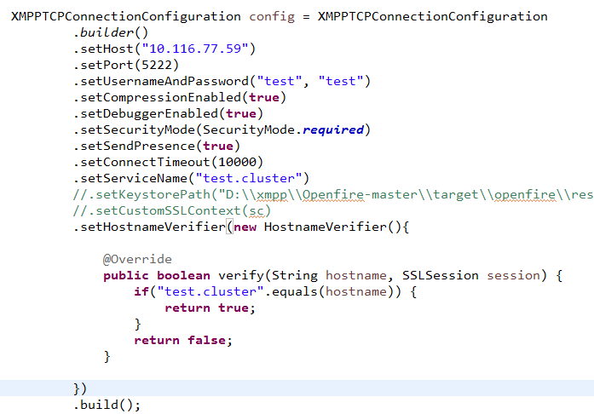

Running Openfire

* VM Args
  + export OPENFIRE_HOME=<PATH>
  + -Xbootclasspath/p:$OPENFIRE /lib/npn-boot-1.1.10.v20150130.jar -DopenfireHome=$OPENFIRE_HOME -Dopenfire.lib.dir=$OPENFIRE /lib
* Cluster -- HazelcastPlugin

Modify hazelcast-cache-config.xml

For each node, all add node entry in /etc/hosts

<join><multicast enabled="false">

<multicast-group>224.2.2.3</multicast-group>

<multicast-port>54327</multicast-port>

</multicast>

<tcp-ip enabled="true">

<member>nodeA:5701</member>

<member>nodeB:5701</member>

<member>nodeC:5701</member>

</tcp-ip>

<aws enabled="false"/>

</join>

Server properties

ToDo List

1. Register phone, email authentication captucha
2. Register only concern user Id, and password
3. stream management features for XEP-0198

ChatStateManager